Experiment 2-Figma Practical – Bus Ticket Booking System
Sketcha Simple Prototype of a BusTicket Booking System using Figma
Tool Figma CO1

Objective
To design a simple interactive prototype of a Bus Ticket Booking System using
Figma.

Step 1: Login to Figma
1. Open a web browser.
2. Go to figma.com.
3. Click Log in or Sign up.
4. Login using:
o Google account, or
o Email and password.
5. After successful login, the Figma Home page will appear.

Step 2: Create a New Design File
1. From the Figma Home page, click New design file.
2. A blank design canvas will open.
3. Click the file name at the top-left corner.
4. Rename the file as:
Bus Ticket Booking Prototype

Step 3: Create a Mobile Frame
1. Select the Frame Tool from the toolbar.
2. Alternatively, press F on the keyboard.
3. From the right-side panel, select a mobile device.
4. Choose a suitable size such as:
375 × 812 px
5. Rename the frame:
Home Screen
This frame represents the mobile application screen.

Step 4: Design the Home Screen
Create the main booking screen.
4.1 Add Header
1. Select the Text Tool (T).
2. Click near the top of the frame.
3. Type:
Bus Booking App
4. Increase the font size and make it bold.
4.2 Add From City
1. Select Rectangle Tool (R).
2. Draw a rectangular input box.
3. Add text:
From City
4.3 Add To City
Create another rectangle below the first one.
Add:
To City
4.4 Add Travel Date
Create another input box.
Add:
Travel Date
4.5 Add Search Button
1. Draw a rectangle below the input fields.
2. Add text:
Search Buses

The completed screen should contain:
Bus Booking App
↓
From City
↓
To City
↓
Travel Date
↓
Search Buses

Step 5: Design the Bus List Screen
1. Select the Home Screen frame.
2. Duplicate it using Ctrl + D.
3. Move the duplicated frame beside the first frame.
4. Rename it:
Bus List Screen
Remove the unnecessary home-screen elements and add the following.
Bus Listing 1
Chennai → Bangalore
ABC Travels
08:00 AM
₹650
Book Now
Bus Listing 2
Chennai → Bangalore
XYZ Travels
10:30 AM
₹750
Book Now
Bus Listing 3
Chennai → Bangalore
Express Travels

01:00 PM
₹600
Book Now
Arrange the bus details neatly using rectangles/cards.

Step 6: Design the Seat Selection Screen
1. Duplicate the Bus List Screen.
2. Rename it:
Seat Selection Screen
3. Remove the bus listings.
4. Add the heading:
Select Your Seat
Create Seat Grid
1. Select the Rectangle Tool.
2. Draw a small rectangle representing one seat.
3. Duplicate the seat using Ctrl + D.
4. Arrange the seats in rows and columns.
Example:
SEAT SELECTION

[01] [02] [03] [04]

[05] [06] [07] [08]

[09] [10] [11] [12]

[13] [14] [15] [16]
5. Make one seat a different color to indicate:
Selected Seat

6. Add a button:
Proceed to Payment

Step 7: Design the Payment Screen
1. Duplicate the Seat Selection Screen.
2. Rename it:
Payment Screen
3. Add the heading:
Payment
4. Add a ticket summary:
Bus: ABC Travels
Route: Chennai → Bangalore
Seat: 05
Date: 15-Oct-2026
5. Add:
Total Price: ₹650
6. Add a payment method field:
Payment Method
Example options:
• UPI
• Credit/Debit Card
• Net Banking
7. Add a button:
Pay Now

Step 8: Create Confirmation Screen
1. Duplicate the Payment Screen.
2. Rename it:
Booking Confirmation
3. Remove unnecessary payment fields.

4. Add:
✔ Booking Confirmed
Then add:
Ticket No: BUS20261001
Passenger: Student Name
From: Chennai
To: Bangalore
Date: 15-Oct-2026
Seat: 05
Amount: ₹650
5. Add a button:
Download Ticket

Step 9: Create Prototype Links
Now connect all the screens.
1. Select the Home Screen.
2. Click the Prototype tab in the right-side panel.
3. Select the Search Buses button.
4. Drag the prototype connection arrow to:
Bus List Screen
Create the following connections:
Button Connect To
Search Buses Bus List Screen
Book Now Seat Selection Screen
Proceed to
Payment Payment Screen
Pay Now Booking Confirmation
Download Ticket Confirmation/Final

Screen
The complete flow is:
Home Screen

↓
Search Buses
↓
Bus List Screen
↓
Book Now
↓
Seat Selection
↓
Proceed to Payment
↓
Payment Screen
↓
Pay Now
↓
Booking Confirmation

Step 10: Preview the Prototype
1. Click the Play ▶ / Present button.
2. The prototype will open in preview mode.
3. Click Search Buses.
4. Check whether the Bus List Screen opens.
5. Click Book Now.
6. Check whether the Seat Selection Screen opens.
7. Click Proceed to Payment.
8. Click Pay Now.
9. Verify that the Booking Confirmation screen appears.
Check the following:
☑ Buttons are clickable
☑ Screens open in the correct order
☑ Seat selection works as designed
☑ Payment screen appears correctly
☑ Confirmation screen is displayed

Step 11: Save and Share

1. Figma automatically saves your design.
2. Click Share in the top-right corner.
3. Select the appropriate sharing permission.
4. If permitted by your Figma account/institution, select:
Anyone with the link → Can view
5. Click Copy link.
6. Submit the Figma link as required.

Expected Screens
Your final prototype should contain at least 5 screens:
1. Home Screen
2. Bus List Screen
3. Seat Selection Screen
4. Payment Screen
5. Booking Confirmation Screen
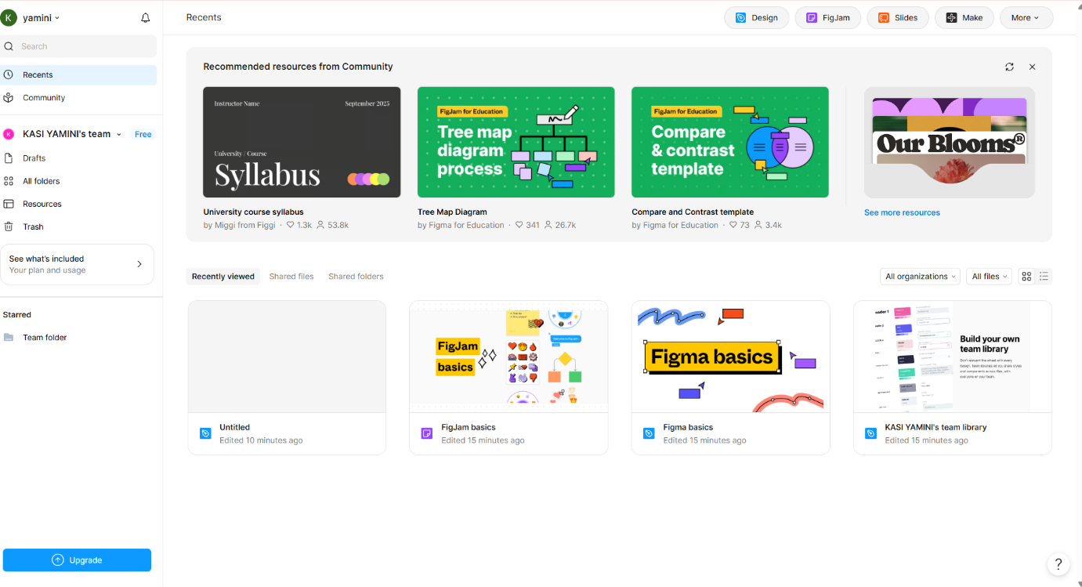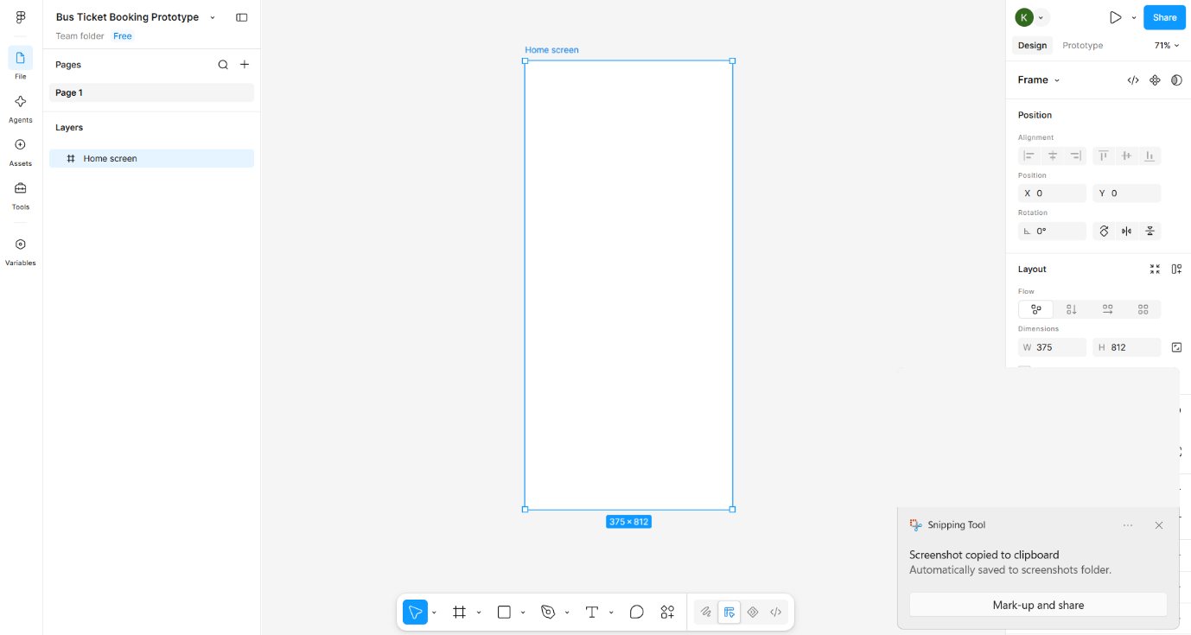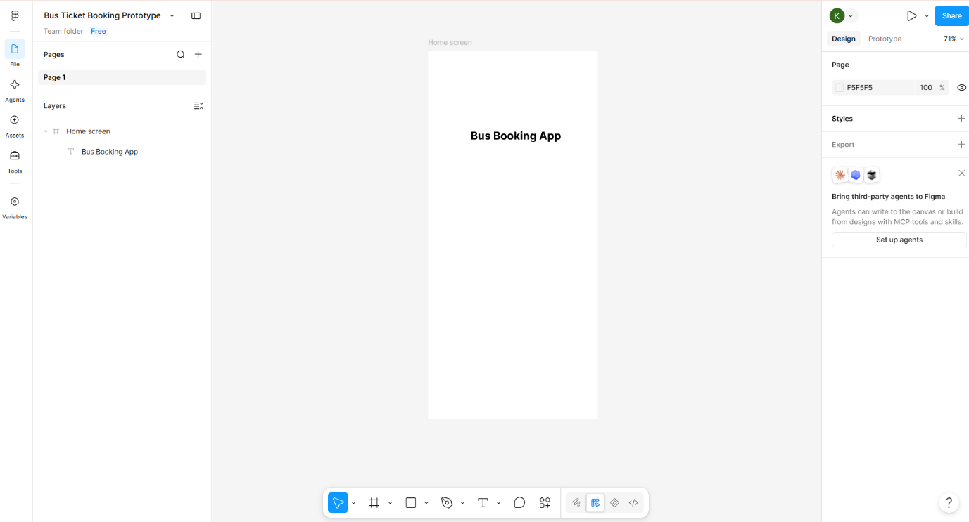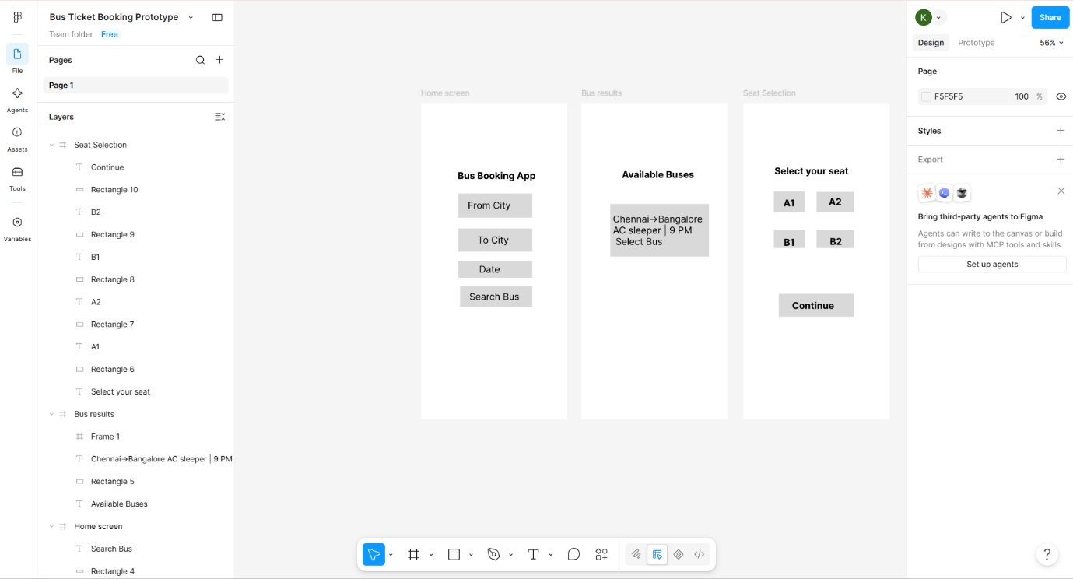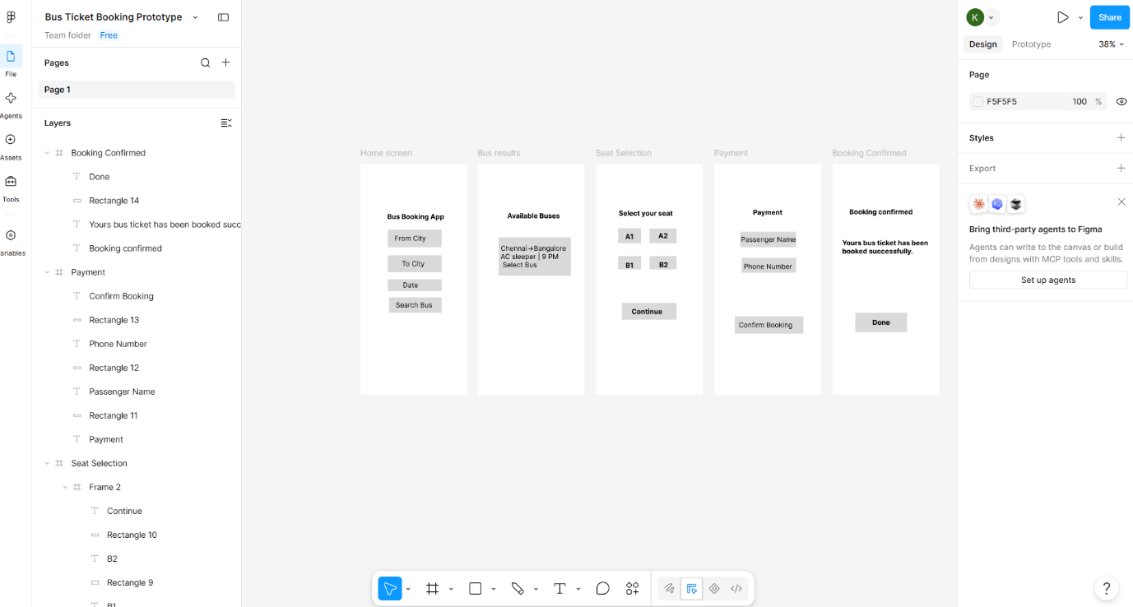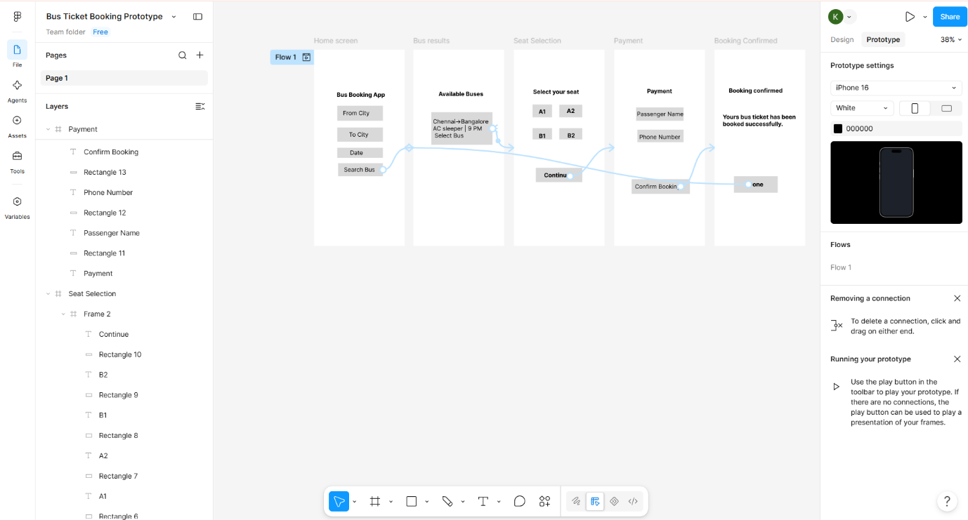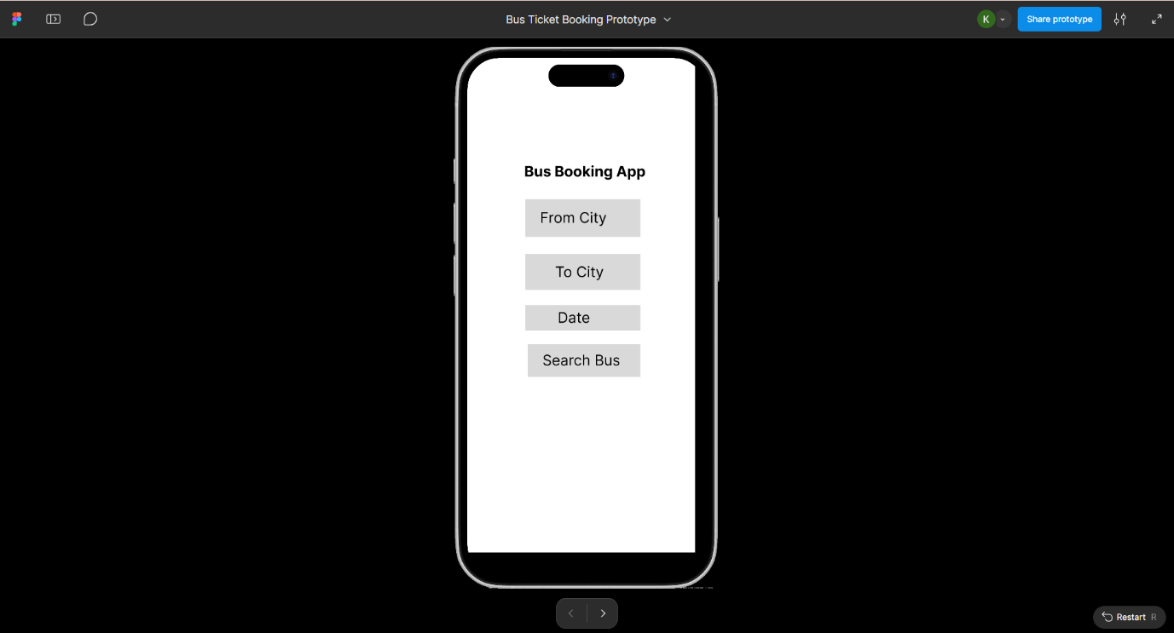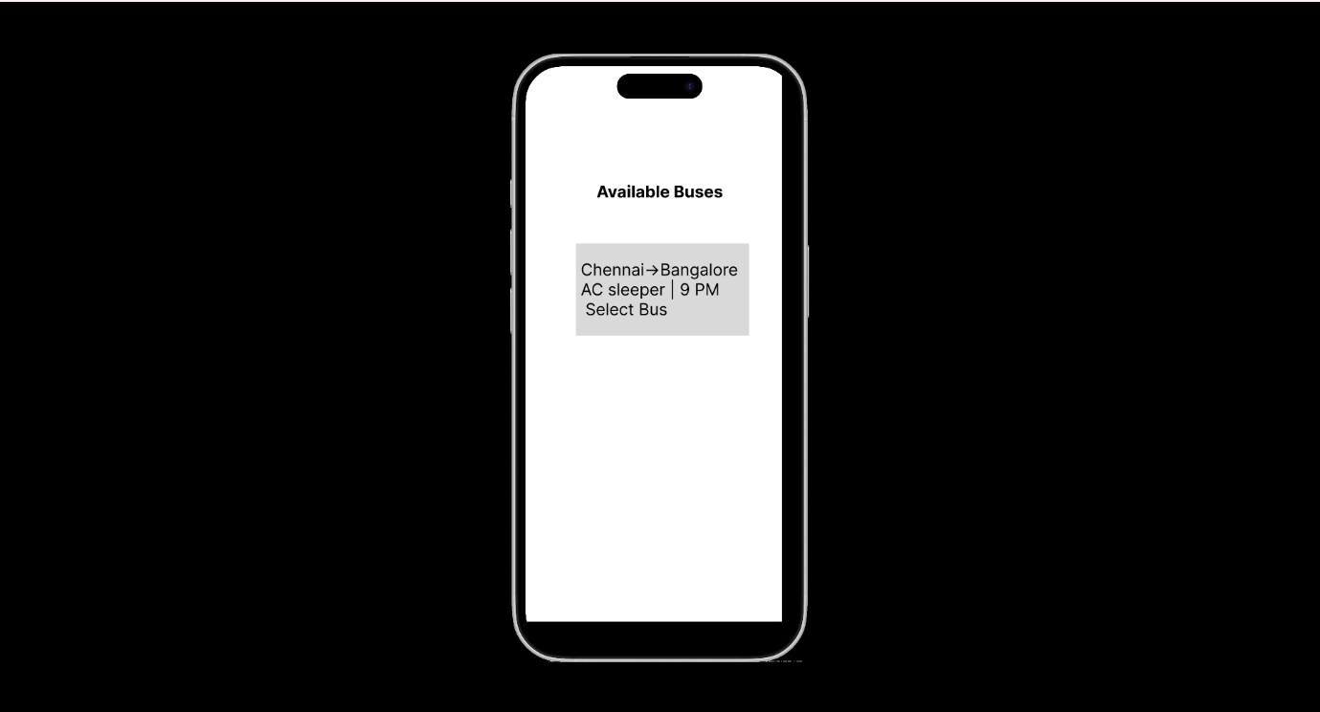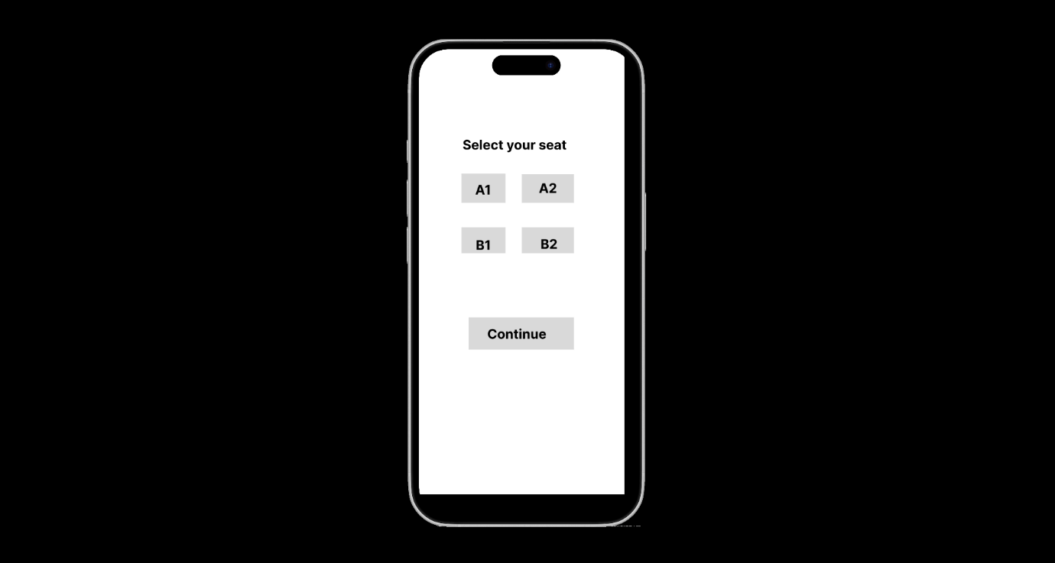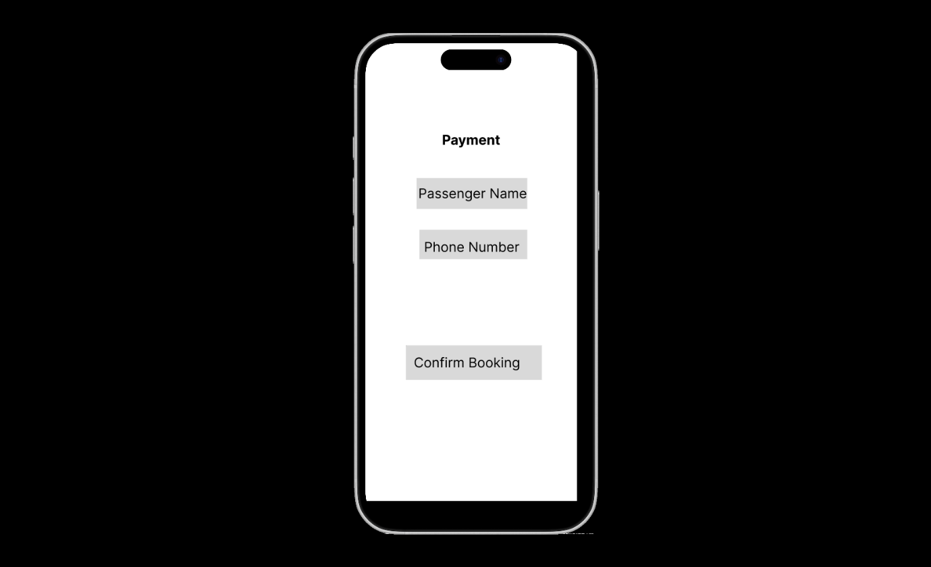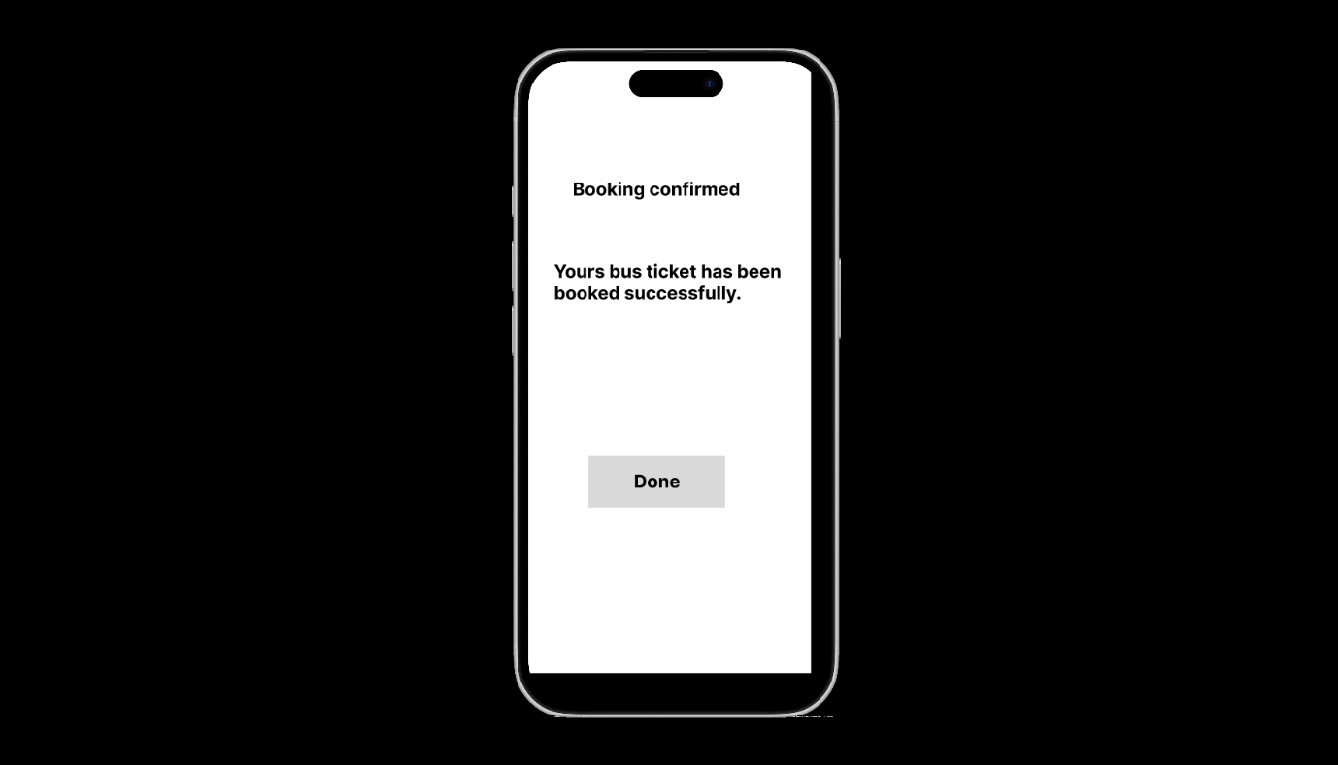
Result
Thus, a simple interactive prototype of a Bus Ticket Booking System was
successfully designed using Figma. The prototype includes bus search, bus
selection, seat selection, payment, and booking confirmation screens with
appropriate navigation between them.

